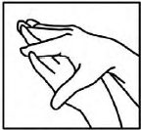

Palm to palm
The back of the fingers
The thumbs
The tips of the fingers
In between the fingers
The back of the hands

